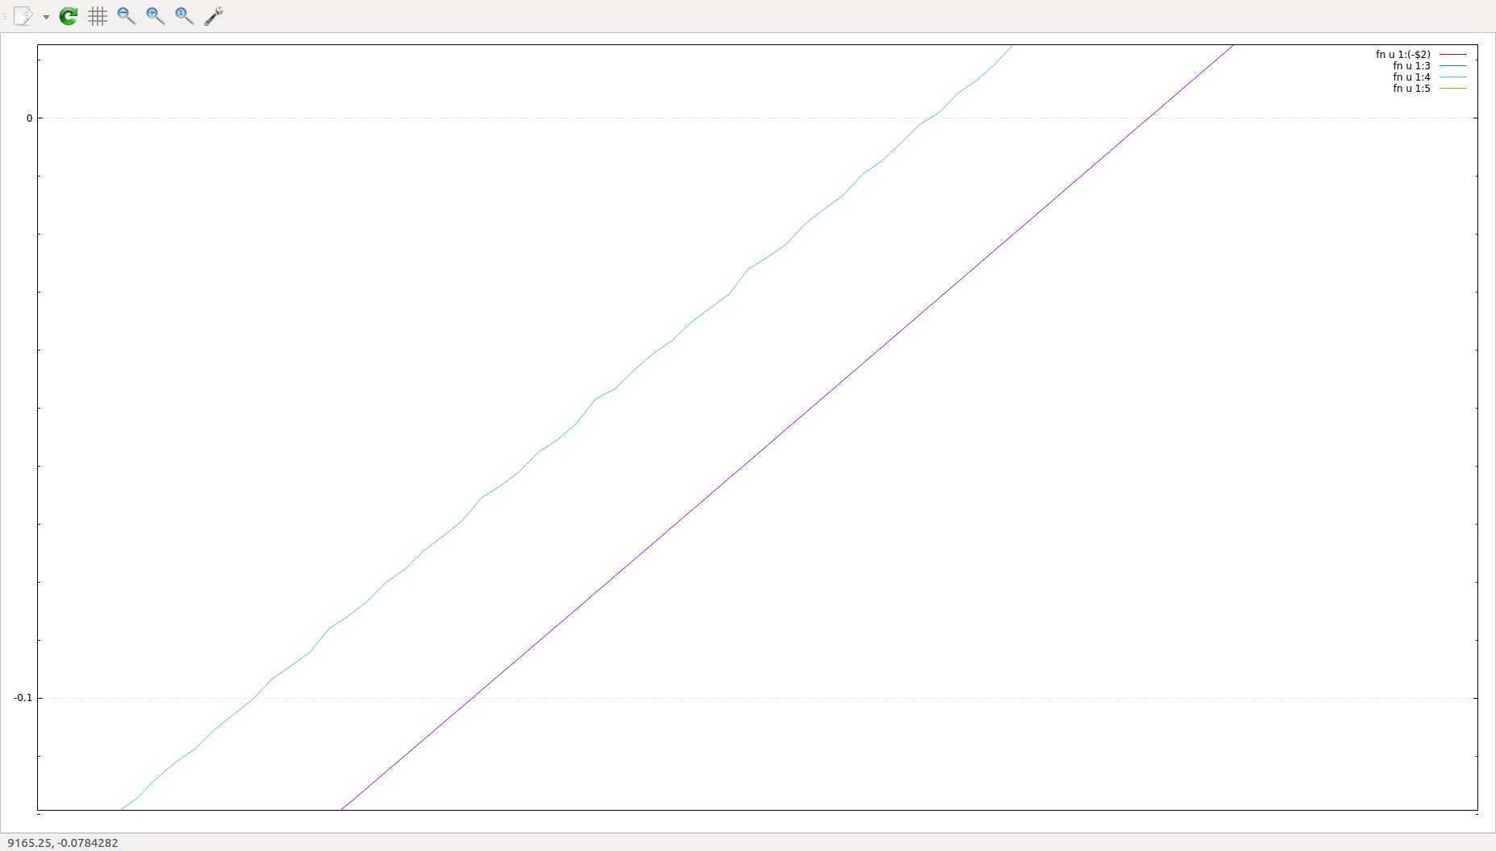
Fig. X Jitter due to 60us sampling window of 14488 Magnetometer (light blue line)

Rotating Collar Theoretical Group Delay

E = angular error = tan⁻¹[μ_{O}ω(OD²-ID²)/16R]

Where:
μ_{o} = 1.2566e-6
ω = 1hz
OD = 7.225”/(39.37”/m) = 0.183515m
ID = 5”/(39.37”/m) = 0.127m
R = 7.8E-07 ohm-m

E = tan⁻¹[1.2566e-6*2π(0.183515²-0.127²)/(15*7.8e-07)]
= 0.01110219rad
E(deg) = 0.01110219*180/π = 0.636109
t_{gd} = ((phase/shift)/360)*t_{per} = (0.636109/360)*1s = 1.77ms

Base measurement (no collar, just group delay of mags)

1hz phase shift
( 1394.35 - 1382.45 )/( 3619.42 – 1394.34 ) * 360 = ( 11.9 / 2225.08) * 360 = 1.925 degrees
2hz phase shift
( 11685.3 - 11682.9 )/( 12797.8 – 11685.3 ) * 360 = ( 2.4 / 1112.5 ) * 360 = 0.777 degrees

tgd = -(phase2-phase1)/360 * 1second = (1.925-0.777)/360 = 3.19ms
Second check mags in “675” collar (not actual 675, but same material):

Measurement of Rotating Collar Plus 14488 Magnetometer

1hz phase shift
(1980.88-1976.41)/( 4201.45 - 1976.41 ) * 360 = (4.47/2225.04)/-0.723 degrees
2hz phase shift
( 12553.2 - 12545.8 ) / ( 13658.3 - 12545.8 ) * 360 = (7.4/1112.5) = -2.395 degrees

phase1 = offset + tgd*omega1
phase2 = offset + tgd*omega2
tgd = -(phase2-phase1)/(omega2-omega1)
= (2.395deg-0.723deg)*pi/180 / ( 2pi*(2-1) )
= (1.672deg/360)*1second
= 4.64ms

Phase Shift caused by Rotating Collar

4.64ms-3.19ms = 1.45ms

Phase shift calculated from the 675-like collar provided and the assumption it is made of P550 material:

1.77ms

Error:

1.77ms – 1.45ms = 0.32ms

